
QUALITY ALERT

Customer: ORAN Date: July 31, 2024
Die: 15360 Colour: All
Type of Complaint: ORAN REJECTED

Q.A # Q.I.R # CUSTOMER NCR #

Description: Customer REJECTED due to material powder being mixed with regrind.

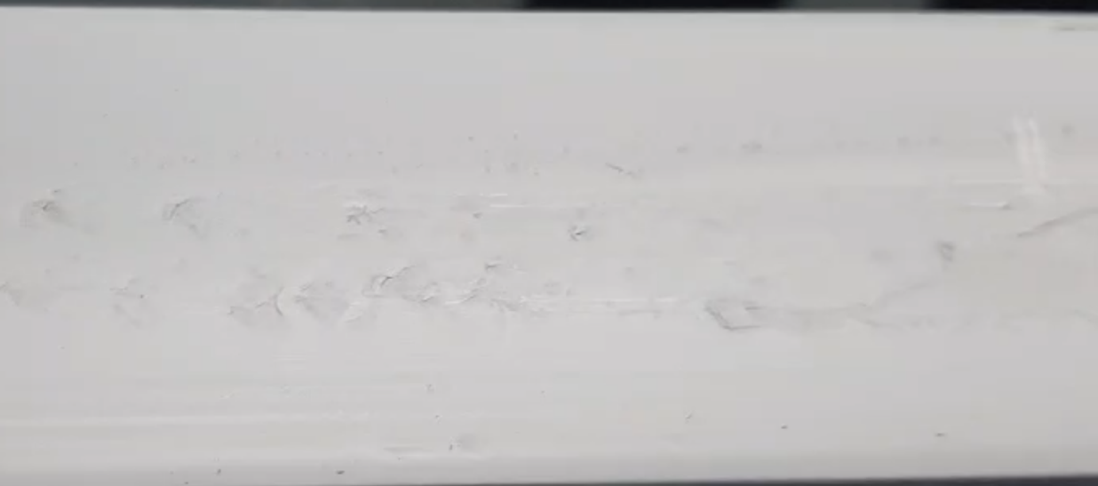

PLEASE MAKE SURE MATERIAL IS NOT MIXED REGRIND

BY SIGNING BELOW, YOU ACKNOWLEDGE THE PROBLEM ABOVE AND AGREE TO MONITOR THIS ISSUE IN FUTURE PRODUCTION RUNS.
DAY SHIFT |  | AFTERNOON SHIFT |  | NIGHT SHIFT
NAME | SIGNATURE | NAME | SIGNATURE | NAME | SIGNATURE

